First A. Author^{1,2}, Second B. Author, Jr.², and Third C. Author²
¹ School of Engineering, The University of Tokyo, 7-3-1 Hongo, Bunkyo-ku, Tokyo 113-8656, Japan
² RCAST, The University of Tokyo, 4-6-1 Komaba, Meguro-ku, Tokyo 153-8904, Japan

Paper Title for LTB-3D
Abstract—A short summary (max 300 characters) of the work can go here. A short summary of the work can go here. A short summary of the work can go here. A short summary of the work can go here. A short summary of the work can go here. A short summary of the work can go here.

INTRODUCTION And BACKGROUND
This document is a template derived from the standard IEEE style template for papers and transactions (http://www.ieee.org/web/publications/authors/transjnl/index.html). The template is for Microsoft Word versions 6.0 or later.
This template should be used for summary submissions to the 6th International Conference on Low Temperature Bonding for 3D Integration or LTB-3D 2019 to be held from May 21-25, 2019, at Ishikawa Prefectural Noh Theater (Nogakudo). Please refer to the conference website for details, including registration and final paper submission information: http://www.3dwb.org/index.html

The length limit for summary submissions is one page for all contributed papers, including both oral and poster presentations. Summaries should be submitted in pdf format. Please do not password protect your PDF file. Please, do not number your pages.
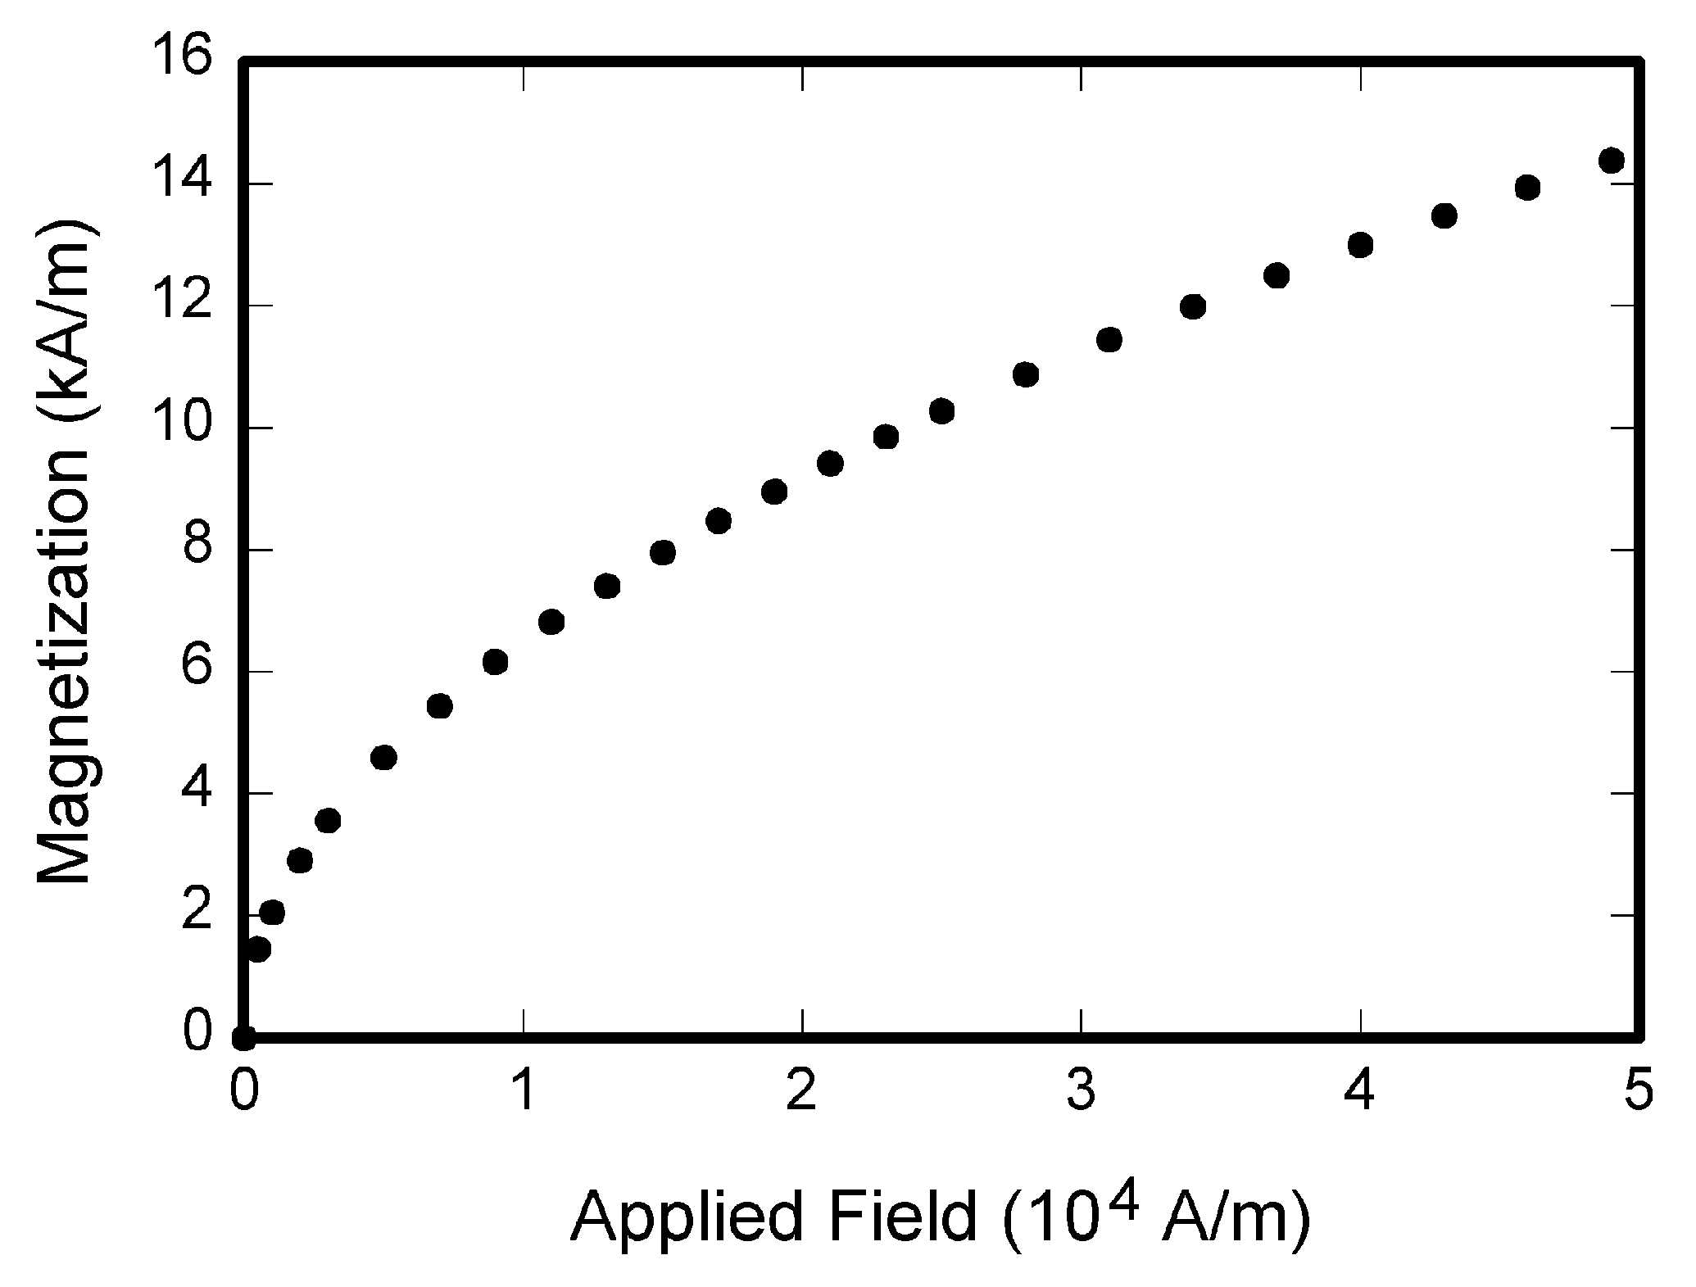
Fig. 1. Magnetization as a function of applied field. Note that “Fig.” is abbreviated. There is a period after the figure number, followed by two spaces. It is good practice to explain the significance of the figure in the caption.

RESULTS
This section describes the results¹. This section describes the results. This section describes the results. This section describes the results. This section describes the results. This section describes the results. This section describes the results. This section describes the results. This section describes the results. This section describes the results. This section describes the results. This section describes the results. This section describes the results.
This section describes the results. This section describes the results. This section describes the results. This section describes the results. This section describes the results. This section describes the results. This section describes the results. This section describes the results. This section describes the results. This section describes the results.
Figures: Format and save your graphic images using a suitable graphics processing program that will allow you to save the images as a jpeg file, for example, and then insert the figure inline with the text using the Insert→Picture→From-File menu.

A conclusion section is not required.

Acknowledgment
The preferred spelling of the word “acknowledgment” in American English is without an “e” after the “g.” Use the singular heading even if you have many acknowledgments.

References
- G. O. Young, “Synthetic structure of industrial plastics (Book style with paper title and editor),” in Plastics, 2nd ed. vol. 3, J. Peters, Ed. New York: McGraw-Hill, 1964, pp. 15–64.
- W.-K. Chen, Linear Networks and Systems (Book style). Belmont, CA: Wadsworth, 1993, pp. 123–135.
- H. Poor, An Introduction to Signal Detection and Estimation. New York: Springer-Verlag, 1985, ch. 4.

